**Project Proposal[1] :** *Members Record Management System(GotoGro-MRM)*

*Group member:*

1. Vighnesh A/L Ganapathi (Cyber Security) – 104057178
2. Ngau Yong Sheng (Data Science) – 103526703
3. Chiam Jun hao (Cyber Security) – 103526716
4. Liew Chan Yeong Derrick(Data Science)-103536663
5. Yit Kim Leong (Software Development) - 103710331

*Tutorial: Thursday 8-10am*

*Lecture: Ms Robina*

Solution Direction

* Web based application
* Mobile application

Problem Domain

*Goto Grocery is a member-based grocery store based in Hawthorn. They offer quality grocery items for our members. Currently they are using a paper-based system to record our members details and their(members) sales records. Recently, they found it difficult to manage their members expectation. They find it difficult to satisfy their members grocery needs. They often ordered items that are not needed by their members. They need an application that can help them to manage their members records and inform them their(members) grocery needs in a timely manner.*

Solution Domain

Is to create an application that help the staff to keep track of their customers details and their purchases. The application will also help to reduce the time spent compared to paper-based system and also could minimize errors such as ordering items which are not needed by the members.

Similar software / competitors

* Tesco Online
* HappyFresh
* GrabMart
* Signature Market
* Jaya Grocer

Knowledge in this company

1. Vighnesh – My knowledge in this company is , it sell grocery items to it’s members regularly by ordering necessaries items for their members. Currently they are using paper-based system to track, record their members and also to order grocery items for their member where it cause to order items which are not necessaries for their members.

2. Yong Sheng – all I understand is this company sells groceries and it also keep track of their customers details. Currently they are still using paper base documents to record down their customer information.

3. Chiam Jun Hao – To my acknowledgement on this company is they are selling fresh grocery items every day. But they are using paper-based to record down all the information like customer information, grocery stock amount and many more which is not ideal for modern days.

4. Derrick Liew – My knowledge in this company is that they sell their grocery to their customer and in the same time they also still using the paper-based system to record the customer information which may cause inconvenient in the future.

5. Yit Kim Leong - From my understanding of this company, it makes sales of fresh groceries to customer and keeps track of the daily transactions using a paper-based approach. This might be problematic as it would be hard to filter out specific transactions and lead to many other problems such as missing records and more when so many sales are made everyday.

Experience in coding language

1. Vighnesh – I have experience in HTML, PHP. JavaScript and C# which I have learnt and also done some projects during my diploma time.

2. Ngau Yong Sheng -I’m quite familiar with HTML,PHP and JavaScript coding language, I’ve been using these three languages to code since diploma’s days. The database server I’m familiar with is MySQL phpMyAdmin .

3. Chiam Jun Hao – I have web-based coding experience like HTML, JavaScript and PHP for front end experience. And for back end I have experience on SQL + PHP coding for data storing during diploma.

4. Derrick- I have experience in HTML,PHP,JavaScript,C++,C#, SQLand python which I had learnt in my first year degree

5. Yit Kim Leong - I have experiences in working using HTML, Javascript and C#. I have also worked using mySQL, Python and C++ but not to a level as proficient as the other 3.

Proposed solution (Web or mobile)

1. Vighnesh – Web based application

2. Ngau Yong Sheng – Web based application

3. Chiam Jun Hao – Web based application

4.Derrick Liew- Web based application

5. Yit Kim Leong - Web based application

Diagram

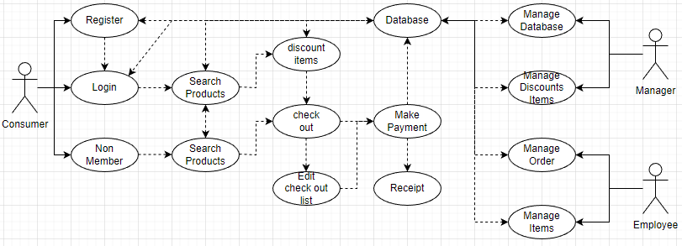

1. This document is by no means a “full project proposal”. It has been simplified and customized for the purposes of SWE30010 teaching. The full project proposal includes many other sections which have not been discussed during the first few weeks of SWE30010 teaching.